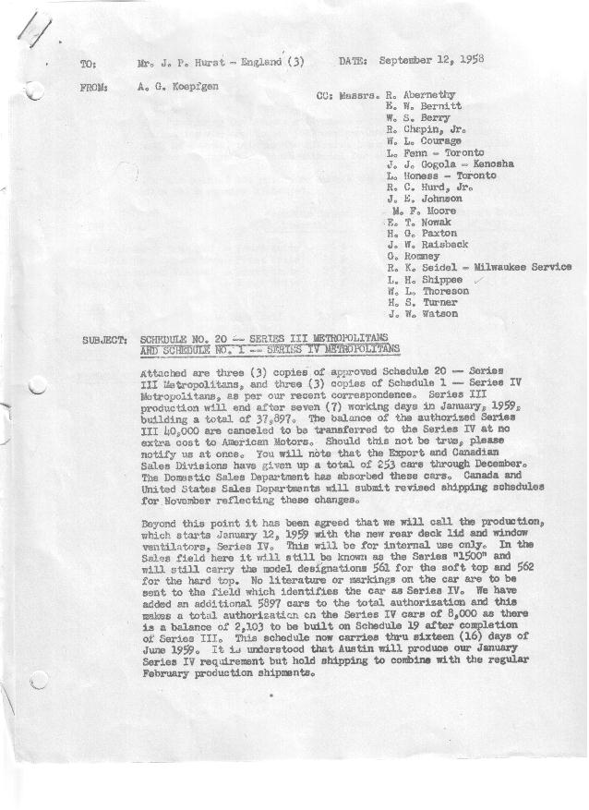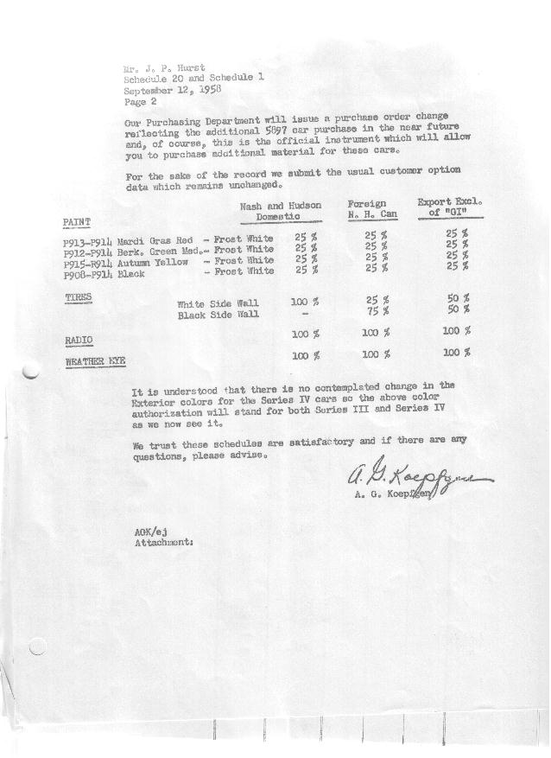

FORM AM 1262 APPROVED R. Abernethy (signed) DATE 9/16/58

SCHEDULE NO. ______1 ___ DATE 9-12-58 MONTHLY BUILDING SCHEDULE APPROVED R. W.Chapin Jr. (signed) DATE_ 9/16/58 _
REVISION NO. _______ ______ DATE PRODUCT APPROVED E.W.Bernitt (signed) DATE _ 9-16-58 ____
SERIES IV 1500 c.c. ENGINE
METROPOLITAN SERIES CARS – AUSTIN MOTORS CO., LTD, ENGLAND
DESCRIPTION | BUILT  ◻ACT◻ EST  THRU | FIRM BUILDING SCHEDULE  (FABRICATED MATERIAL RELEASE) |  |  |  |  |  |  |  |  |  |  |  |  |  |  | TENTATIVE SCHEDULE  (RAW MATERIAL RELEASED) |  |  | GRAND  TOTAL
DESCRIPTION | BUILT  ◻ACT◻ EST  THRU | MONTH JANUARY 1959  DAYS 15 |  |  | MONTH FEBRUARY  DAYS 20 |  |  | MONTH MARCH  DAYS 20 |  |  | MONTH APRIL  DAYS 20 |  |  | MONTH MAY  DAYS 19 |  |  | MONTH JUNE  DAYS 15.7 (22 Available) |  |  | GRAND  TOTAL
DESCRIPTION | BUILT  ◻ACT◻ EST  THRU | DAILY | MONTH | CUM’L  TOTAL | DAILY | MONTH | CUM’L  TOTAL | DAILY | MONTH | CUM’L  TOTAL | DAILY | MONTH | CUM’L  TOTAL | DAILY | MONTH | CUM’L  TOTAL | DAILY | MONTH | CUM’L TOTAL | GRAND  TOTAL
DOMESTIC LHD:
Hard-Top |  |  | 663 | 663 |  | 995 | 1658 |  | 902 | 2560 |  | 906 | 3466 |  | 893 | 4359 |  | 716 | 5075
Soft-Top |  |  | 221 | 221 |  | 332 | 553 |  | 300 | 853 |  | 302 | 1155 |  | 298 | 1453 |  | 238 | 1691
Total U.S. |  | 58.9 | 884 | 884 | 66.4 | 1327 | 2211 | 60.1 | 1202 | 3413 | 60.4 | 1208 | 4621 | 62.7 | 1191 | 5812 | 60.7 | 954 | 6766
Over/(Under) Schedule 19 |  |  | 350 | 350 |  | 611 | 961 |  | 369 | 1330 |  | 1208 | 2538 |  | 1191 | 3729 |  | 954 | 4683
FOREIGN:
EXPORT LHD Hard-Top |  |  | 35 | 35 |  | 35 | 70 |  | 35 | 105 |  | 35 | 140 |  | 33 | 173 |  | 30 | 203
Soft-Top |  |  | 10 | 10 |  | 10 | 20 |  | 10 | 30 |  | 10 | 40 |  | 10 | 50 |  | 9 | 59
Total Export LHD |  |  | 45 | 45 |  | 45 | 90 |  | 45 | 135 |  | 45 | 180 |  | 43 | 223 |  | 39 | 262
RHD Hard Top |  |  | 20 | 20 |  | 20 | 40 |  | 20 | 60 |  | 20 | 80 |  | 20 | 100 |  | 20 | 120
Soft Top |  |  | 5 | 5 |  | 5 | 10 |  | 5 | 15 |  | 4 | 19 |  | 4 | 23 |  | 4 | 27
Total Export RHD |  |  | 25 | 25 |  | 25 | 50 |  | 25 | 75 |  | 24 | 99 |  | 24 | 123 |  | 24 | 147
Total Export LHD & RHD |  | 4.7 | 70 | 70 | 3.5 | 70 | 140 | 3.5 | 70 | 210 | 3.4 | 69 | 279 | 3.5 | 67 | 346 | 4.0 | 63 | 409
Over/(Under) Schedule 19 |  |  | 19 | 19 |  | 10 | 29 |  | 4 | 33 |  | 69 | 102 |  | 67 | 169 |  | 63 | 232
CANADA Hard-Top |  |  | 65 | 65 |  | 60 | 125 |  | 150 | 275 |  | 155 | 430 |  | 130 | 560 |  | 140 | 700
Soft-Top |  |  | 10 | 10 |  | 15 | 25 |  | 50 | 75 |  | 40 | 115 |  | 10 | 125 |  | 0 | 125
Total Canada |  | 5.0 | 75 | 75 | 3.7 | 75 | 150 | 10.0 | 200 | 350 | 9.8 | 195 | 545 | 7.4 | 140 | 685 | 8.9 | 140 | 825
Over/(Under) Schedule 19 |  |  | 58 | 58 |  | 50 | 108 |  | 65 | 173 |  | 195 | 368 |  | 140 | 508 |  | 140 | 648
Total Foreign |  | 9.7 | 145 | 145 | 7.2 | 145 | 290 | 13.5 | 270 | 560 | 13.2 | 264 | 824 | 10.9 | 207 | 1031 | 12.9 | 203 | 1234
Over/(Under) Schedule 19 |  |  | 77 | 77 |  | 60 | 137 |  | 69 | 206 |  | 264 | 470 |  | 207 | 677 |  | 203 | 880
GRAND TOTALS
Hard-Top |  | 52.2 | 783 | 783 | 55.5 | 1110 | 1893 | 55.4 | 1107 | 3000 | 55.8 | 1116 | 4116 | 56.7 | 1076 | 5192 | 57.7 | 906 | 6098
Soft-Top |  | 16.4 | 246 | 246 | 18.1 | 362 | 608 | 18.2 | 365 | 973 | 17.8 | 356 | 1329 | 16.9 | 322 | 1651 | 15.9 | 251 | 1902
Total |  | 68.6 | 1029 | 1029 | 73.6 | 1472 | 2501 | 73.6 | 1472 | 3973 | 73.6 | 1472 | 5445 | 73.6 | 1398 | 6843 | 73.6 | 1157 | 8000
Over/(Under) Schedule 19 |  |  | 427 | 427 |  | 671 | 1098 |  | 438 | 1536 |  | 1472 | 3008 |  | 1398 | 4406 |  | 1157 | 5563

